OT 7.1 Robotics and 7.2 Types of Robots

# Definitions

## Robot

A robot is an automatically guided machine, which is able to perform tasks on its own.

## Robotics

Robotics is the science of the use and study of robots.

# An Intelligent Robot

## Sensors

An Intelligent robot would have inputs like cameras, microphones, and environmental sensors such as thermometers, accelerometers, and gyroscopes.

## What should it be able to do?

An intelligent robot should be able to perform tasks given to it efficiently and relatively quickly compared to people. It should also be able to understand and interface with people.

# Characteristics of Modern Robots

Some characteristics modern robots should have is a clean design, power efficiency, speed, and an understanding of its surroundings.

# History of Robots

Although mechanical, computerized robots have only been around for less than fifty years, the idea of robots is not so young. Ideas of robots have been though up in the past by the Greeks who spoke of ‘mechanical helpers’ and da Vinci, who drew up plans for a mechanical knight.

During the 1920s, a playwright named Karel Capek wrote a play, which featured human like robots that at first were like slaves, but were given emotions by a scientist, which eventually caused them to turn bad and eliminate the humans and take over the world.

Following the early instances of robots in plays and science fiction stories, robots started to appear in television shows.

# Robot in a TV Show or Movie

## The Robot

Iron Man Suit -> Iron Man, Iron Man II, Iron Man III, The Avengers

## An Image of the Robot

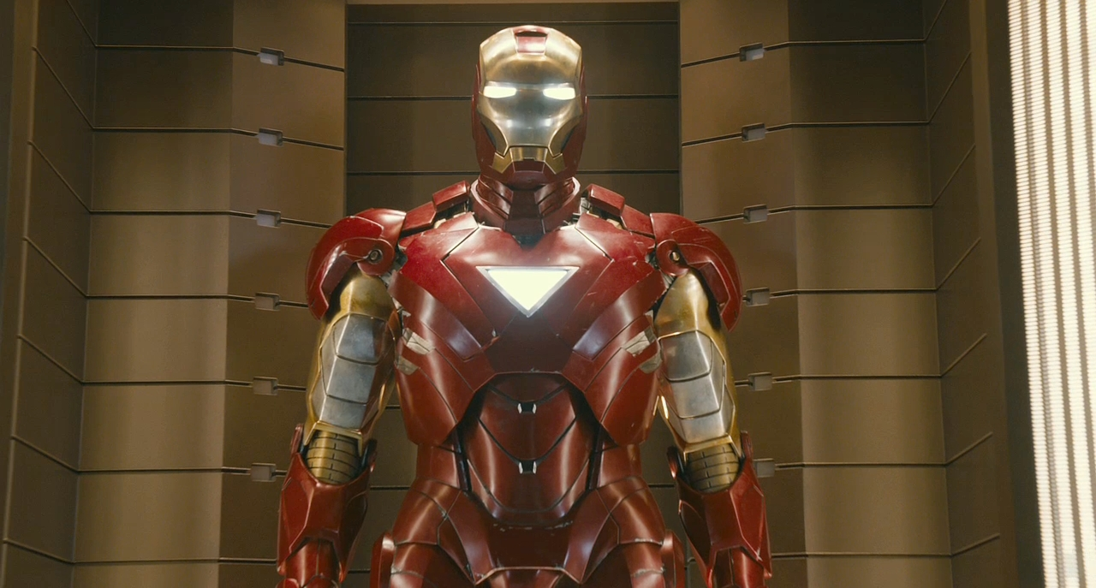

## Its Purpose

Protect and enhance the powers and abilities of the wearer.

## Sensors it is likely to have

Cameras, thermometers, microphones, pressure, barometer, altitude

# Isaac Asimov

Isaac Asimov (1920-1992) took a different view of robots from those writers before him. He was the first to give robots characteristics, which showed respect for humans. Asimov thought robots should be regarded as a very important technological innovation. In 1942, he wrote a story about robots, ‘Runaround’, which contained his Three Laws of Robotics. He later added a fourth law and called it the zeroth law. These laws are:

* Zeroth Law: A robot may not harm humanity, or, by inaction, allow humanity to come to harm.
* First Law: A robot may not injure a human being or, through inaction, allow a human being to come to harm.
* Second Law: A robot must obey the orders given to it by human beings, except where such orders would conflict with the First Law.
* Third Law: A robot must protect its own existence as long as such protection does not conflict with the First or Second Law.

# Stationary vs. Mobile Robots

## A Stationary Robot

Stationary robots are often used in the manufacturing process of products; they stay in on position and manipulate objects via arms with actuators. An example is stationary robots in the manufacturing process of cars, which each complete simple tasks together to build the car.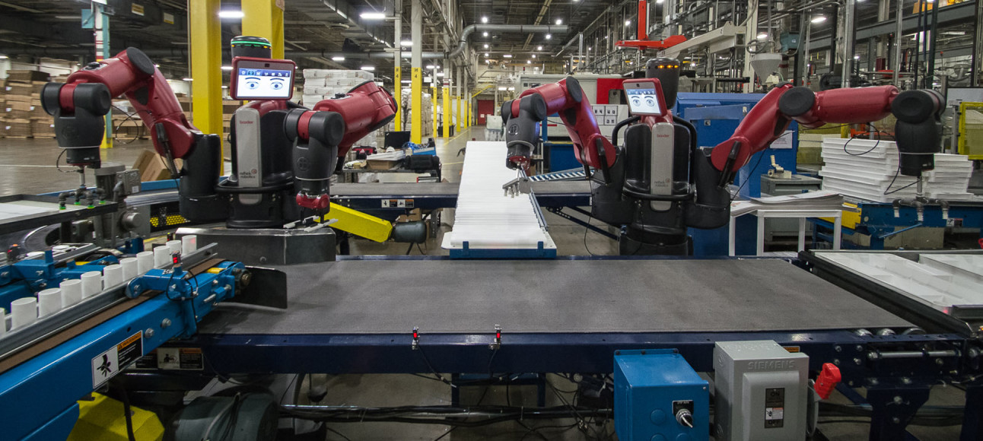

## A Mobile Robot

Mobile robots move around, often on wheels, tracks, or legs. Mobile robots can often do much more than stationary robots because they can move around and some can understand its surroundings. An example of a moving robot is the Roomba, which bumps its way around rooms and vacuums the floor and when it is low on power, it will charge itself by returning to its base station.

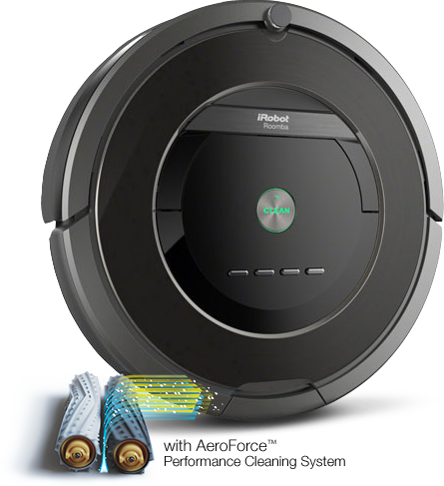

# Industrial Robots vs. Humans

Industrial Robots are preferred over human labor because they are cheaper in the long run, as they do not take holidays or require over time payments, robots do not get sick or sue companies and are more accurate in what they do.

# Macintosh HD:Users:38559:Desktop:ASIMO_4.28.11.jpgAsimo

The Asimo is developed by a Japanese Motor Vehicle Company called Honda.

Asimo is capable of interacting with humans and do tasks such as push a trolley around and receiving a tray from a person. It does this through receiving and processing information from the many sensors it has onboard such as pressure sensors, gyros, and cameras. The Asimo can walk, go up and down stairs, and avoid obstacles. This is done through sensors such as ultrasonic sensors, lasers, infrared sensors, and high dynamic range cameras. Asimo is also intelligent and can interact with humans by receiving information from cameras, microphones, and force sensors.

# Bibliography

Grover, D. (2011). *Information & Software Technology.* Melbourne: Pearson.

Honda. (n.d.). *Inside ASIMO Robotics by Honda | The Technology Behind ASIMO.* Retrieved October 19, 2014, from Asimo.honda.com: http://asimo.honda.com/inside-asimo/

iRobot. (n.d.). *iRobot Roomba Vacuum Cleaning Robot.* Retrieved October 19, 2014, from Irobot.com: http://www.irobot.com/For-the-Home/Vacuum-Cleaning/Roomba.aspx

Marvel. (2013, October). *Iron Man Suit Png - Viewing Gallery.* Retrieved October 19, 2014, from Topinfopost.com: http://topinfopost.com/wp-content/uploads/2013/10/Iron-Man-suit-the-avengers-27152801-1280-687.jpg

Rethink Robotics. (n.d.). *Baxter | Redefining Robotics and Manufacturing | Rethink Robotics.* Retrieved October 19, 2014, from Rethink Robotics: http://www.rethinkrobotics.com/baxter/

Veronica. (2011, April 28). *ASIMO.* Retrieved October 19, 2014, from Wikipedia: http://en.wikipedia.org/wiki/ASIMO#mediaviewer/File:ASIMO\_4.28.11.jpg